**S3 Bucket Creation:**

**Go to S3**

**Click on ‘Create Bucket’ named ‘**[bucket01-basabdatta](https://s3.console.aws.amazon.com/s3/buckets/bucket01-basabdatta)’:

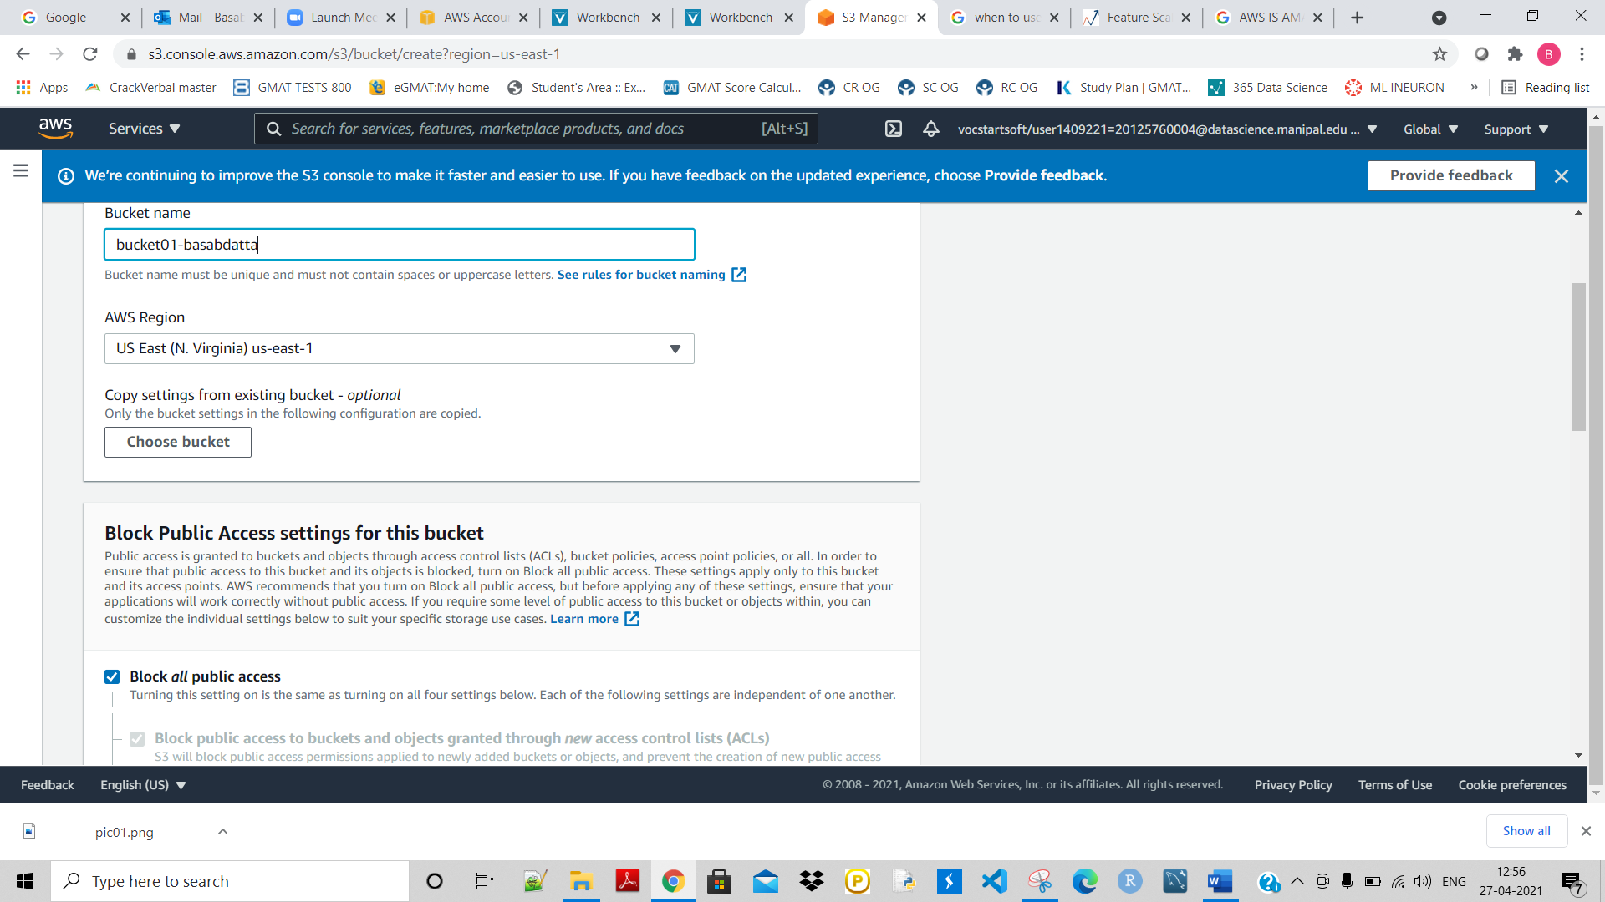

**Give a name to it and click on Create.**

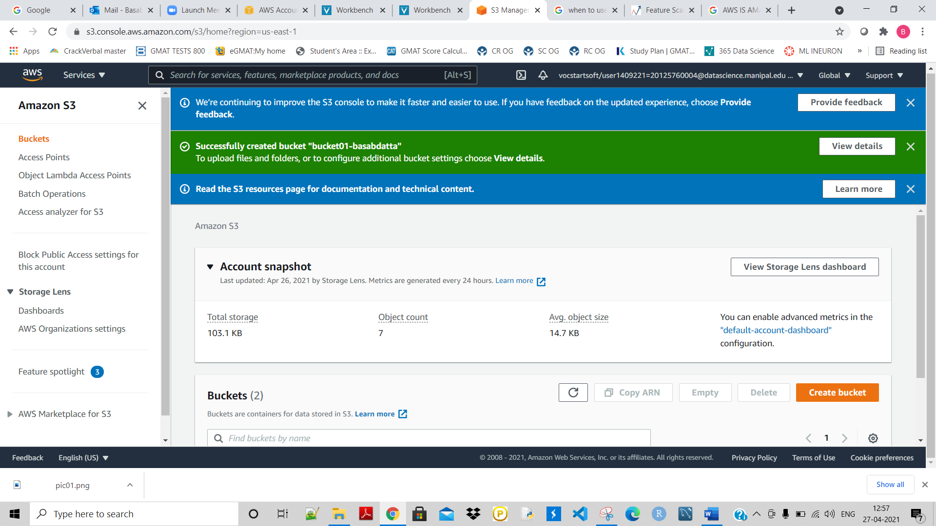

**Now we can upload data/objects over there:**

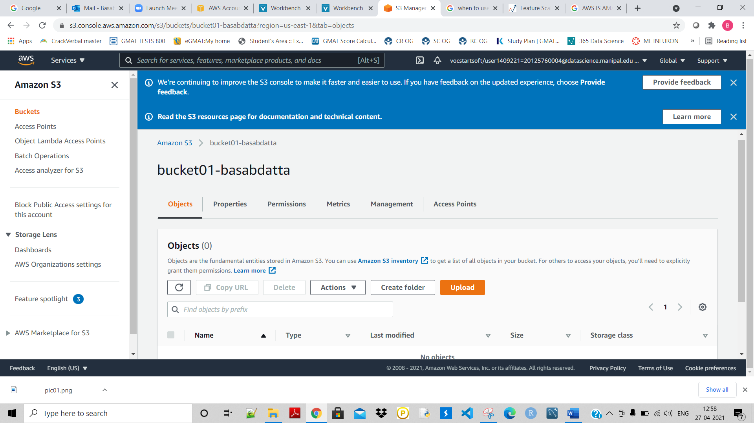

**Click on ‘upload’ and then click on ‘add files’:**

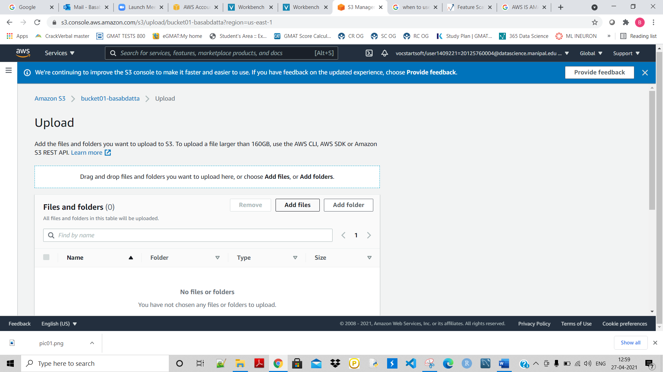

**Here added one file as highlighted:**

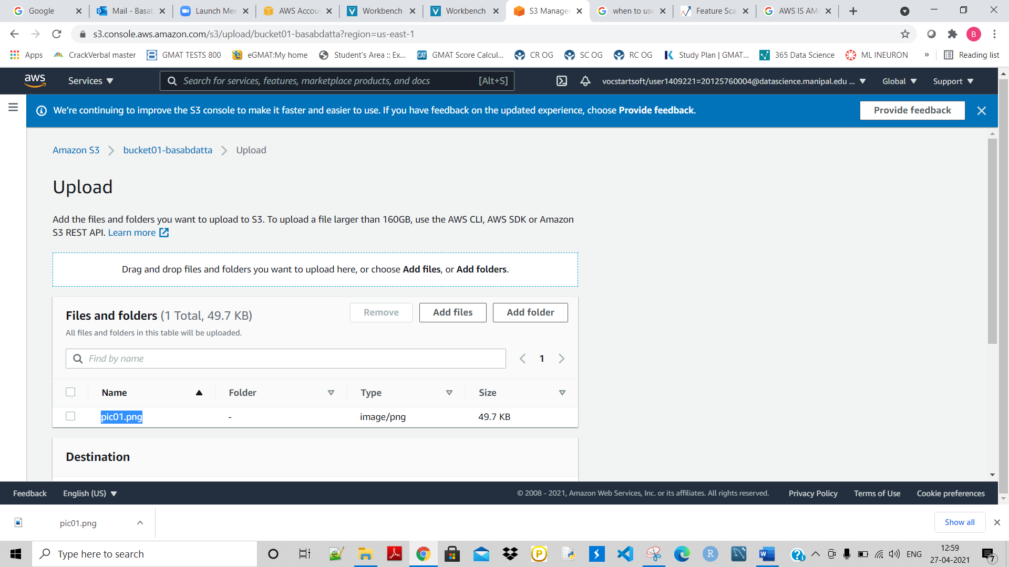

**Now upload it:**

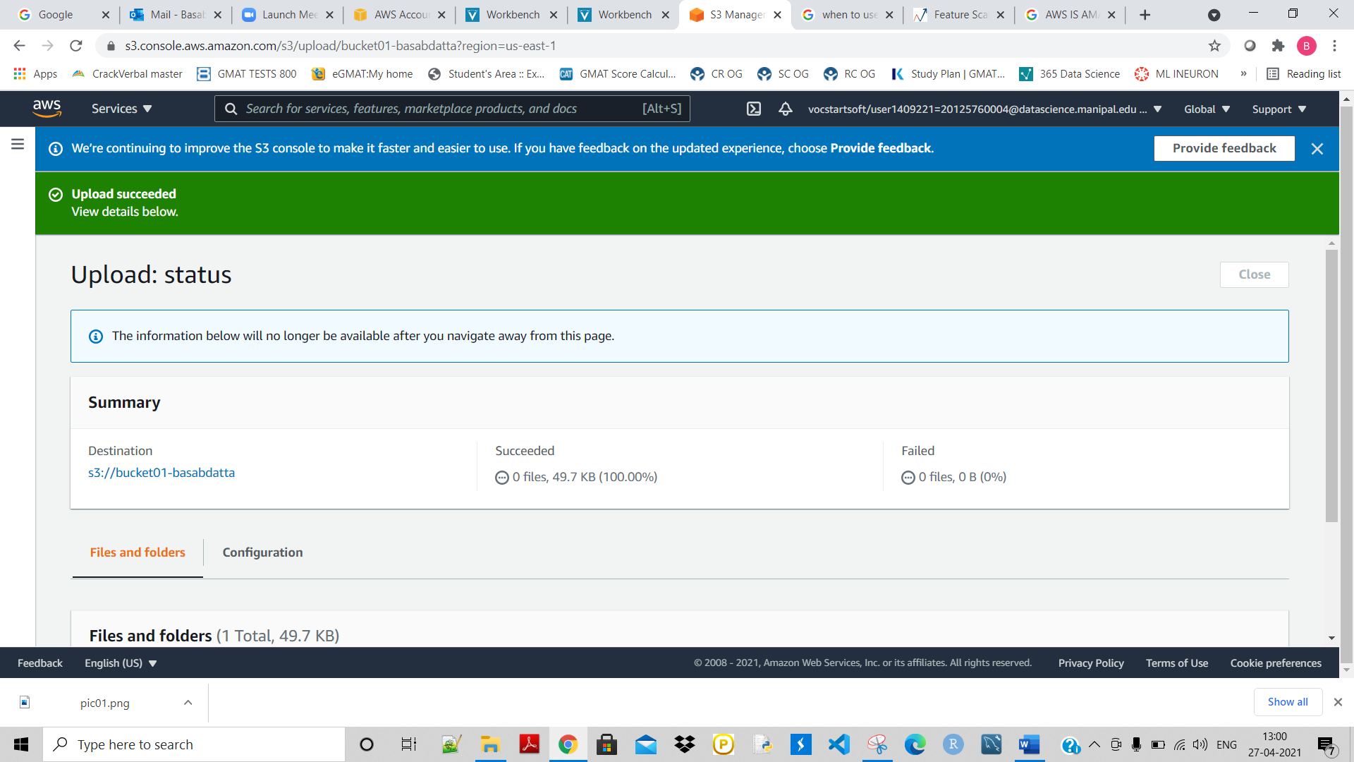

**Created another bucket named ‘**[bucket02-basabdatta](https://s3.console.aws.amazon.com/s3/buckets/bucket01-basabdatta)’, **while creating it I choose** **‘Copy settings from existing bucket – optional’ :**

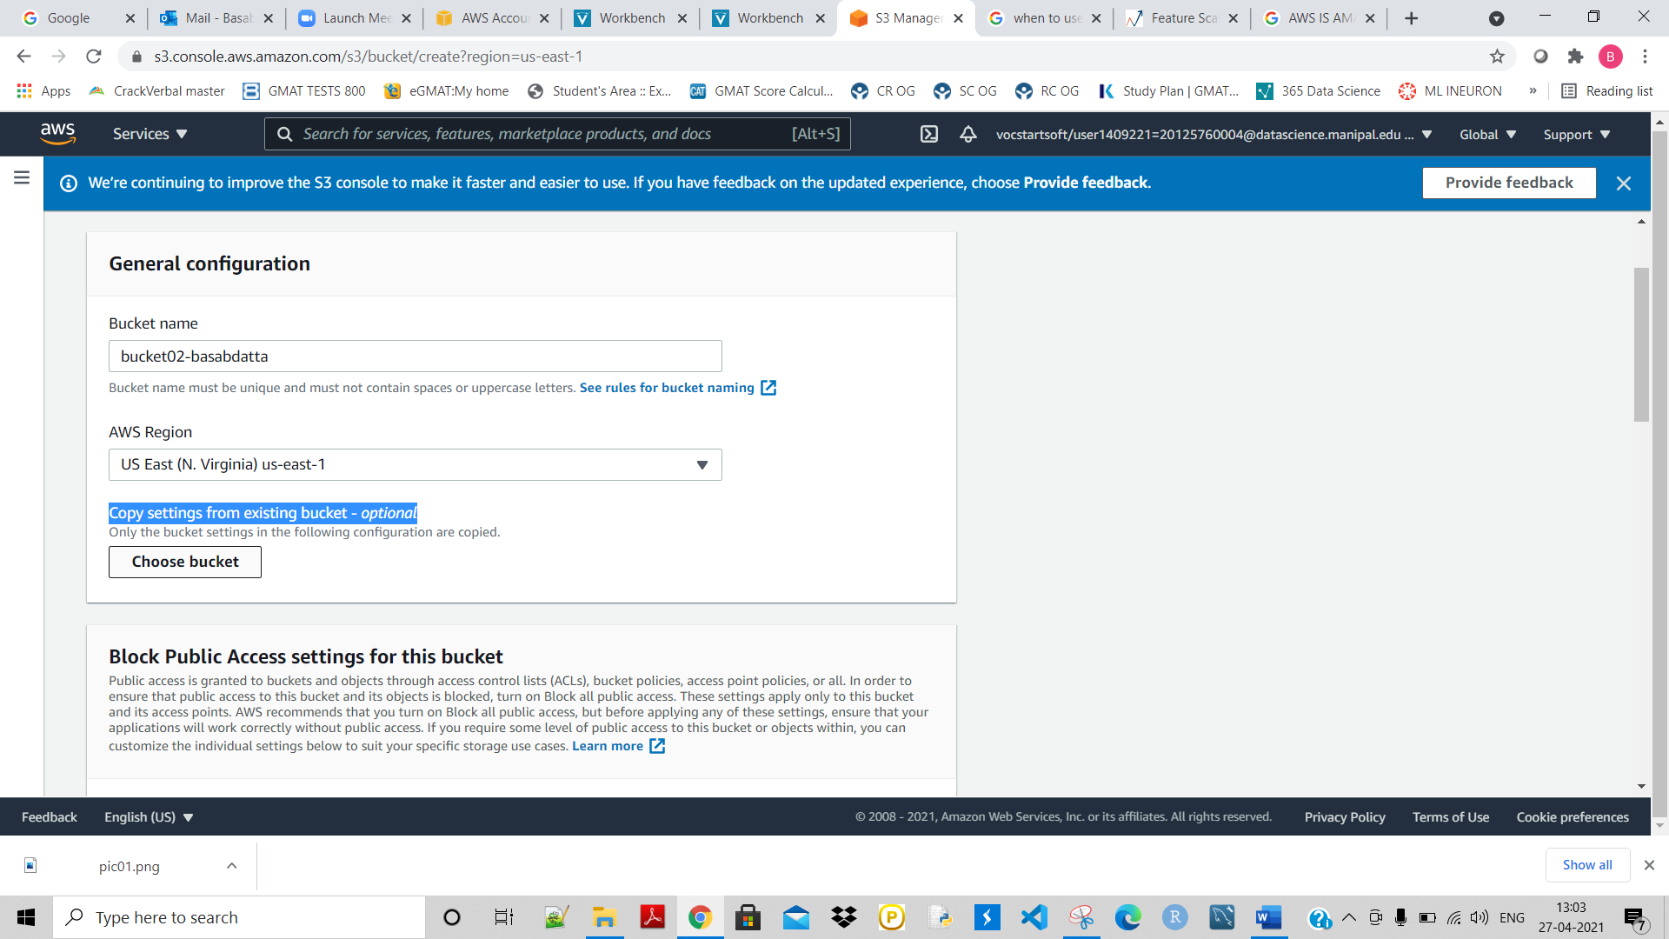

**And then click on ‘Create bucket’.**

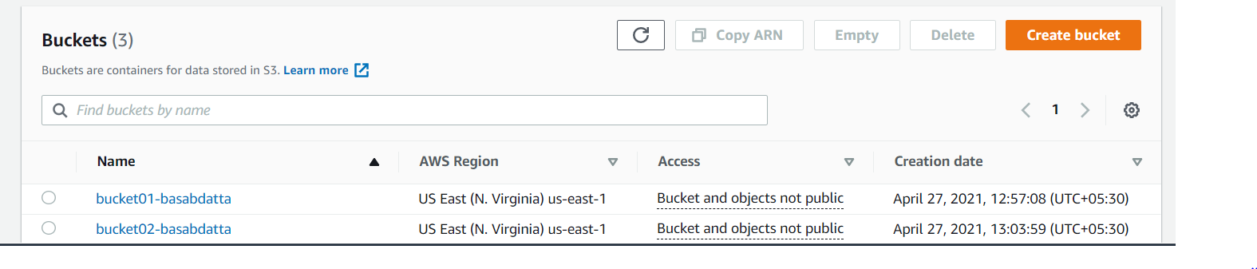

**Next task is to move copy from 1st bucket to the 2nd bucket. Now give the destination name as the 2nd bucket:**

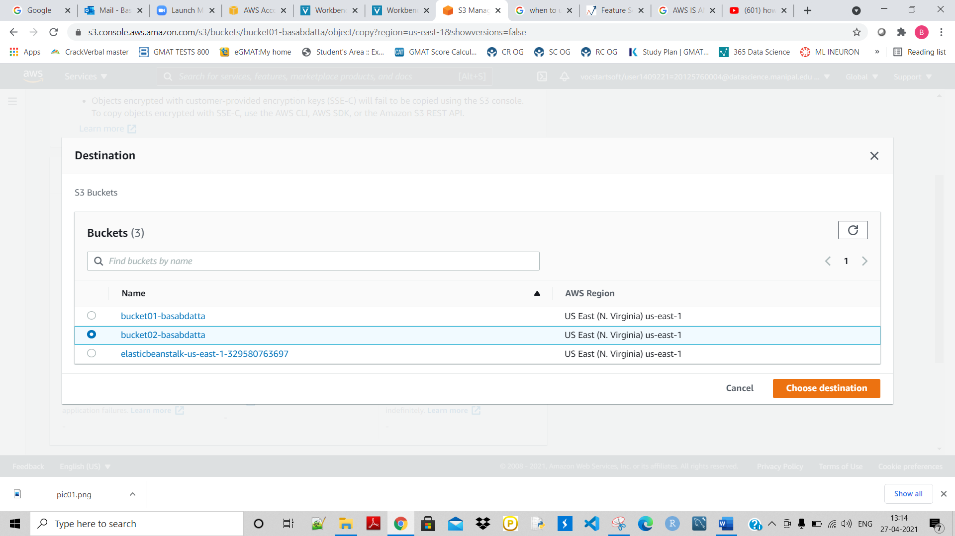

**Select choose destination. And then click on Copy:**

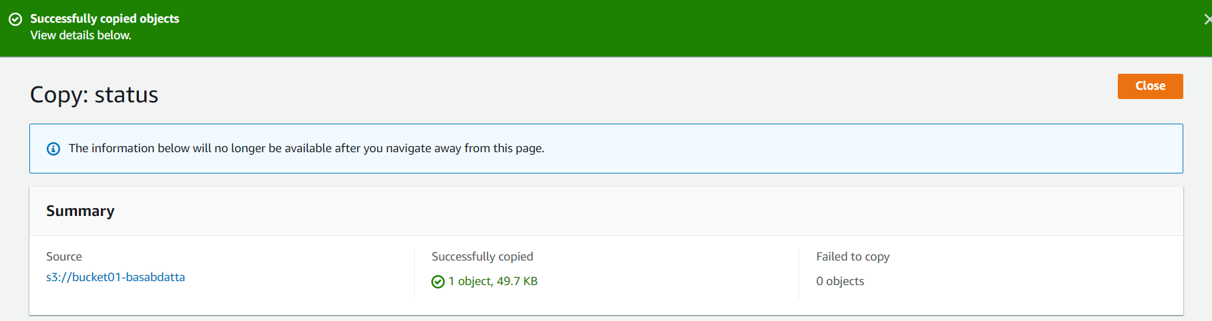

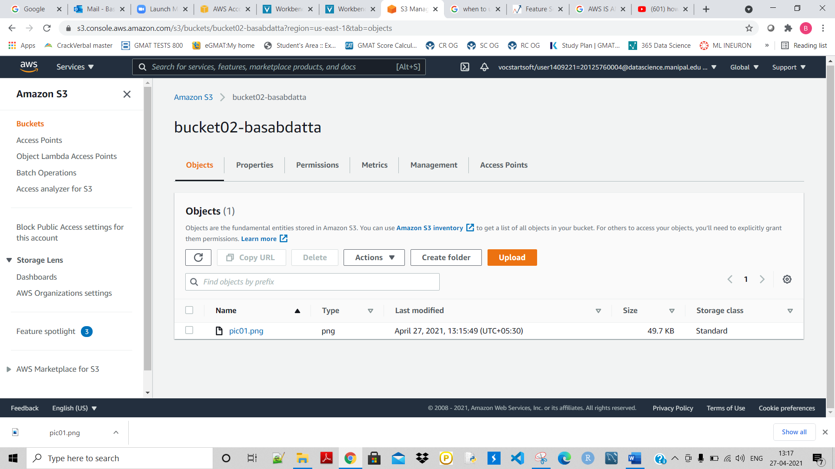

**So now the same file is copied to the 2nd bucket.**